
Use of University of Nottingham Gas and Cryogen Safety Calculator

Title | Use of University of Nottingham Gas Safety Calculator
Version Number | 3
Issue Date | April 2026
Authors | David Kemp

Purpose
This document provides a series of example calculations to aid the use of the in-house University of Nottingham Gas Safety calculators.
The calculators are hosted on the University website (https://www.nottingham.ac.uk/safety/policies-and-guidance/gases/gases.aspx).
The outcome of the calculation can be used as a screening tool to estimate risks to persons in the event of catastrophic and slow leaks of a variety of compressed gases, cryogenic materials, and dry ice.
It is noted that these calculations only form part of the risk assessment, and evidence that a calculation is carried out is not by itself considered a suitable and sufficient assessment of risk. The risk assessment process should still be carried out as normal, and the calculations should only be used to determine who can be harmed, how, and identify the necessary controls.
Note:
This calculator provides estimates for informational purposes only. Assessing exposure to gas is a highly complex field ‐ real-world conditions including gas stratification, turbulent mixing, room geometry, temperature, and ventilation dynamics can differ significantly from the idealised models used here.
This tool must not be used as a replacement for a full risk assessment – it is designed to help you form an opinion but cannot take into account all the possible variables required to accurately provide a recommendation.
If there is any doubt about the risk to people, specialist advice must always be sought from a competent person, or your health and safety coordinator.

Table of Contents
Purpose 1
Outline of Calculator Functionality 3
Part 1: Test Scenarios 5
Scenario 1: Compressed Gas (Asphyxiant) 5
Scenario 2: Liquefied Gas (Toxic) 5
Scenario 3: Cryogenic Vessel (Asphyxiant) 6
Scenario 4: Known Volume (CO₂ Enrichment) 6
Scenario 5: Slow Leak (Flammable) 6
Scenario 6: Toxic Gas, External Lookups & Detection Placement 6
Scenario 7: Slow Leak, Time to Hazard & Heavy Gas Detection 6
Scenario 8: Calculation Risk of Exposure when handling Dry Ice 7
Scenario 9: Mixed Gas Cylinders & Multiple Independent Risks 7
Part 2: Answers & Methodology 7
Scenario 1: Compressed Gas (Asphyxiant) 7
Scenario 2: Liquefied Gas (Toxic) 9
Scenario 3: Cryogenic Vessel (Asphyxiant) 11
Scenario 4: Known Volume (CO₂ Enrichment) 13
Scenario 5: Slow Leak (Flammable) 15
Scenario 6: Toxic Gas, External Lookups & Detection Placement 17
Scenario 7: Slow Leak, Time to Hazard & Heavy Gas Detection 21
Scenario 8: Calculation Risk of Exposure when handling Dry Ice 25
Scenario 9: Mixed Gas Cylinders & Multiple Independent Risks 27
Part 3: Gas/Cryogen Safety Calculator: Mathematical Models 30
1. Volume Calculations 30
2. Room Concentration (Instantaneous Release) 31
3. Continuous Slow Leak (Steady-State) 32
4. Worst-Case Time to Hazard (0 ACH) 32
5. Dry Ice Conversion 34
6. Advanced Leak-Rate Estimator 34
7. Recommendation and Threshold Logic 35
8. Personal Bubble Assessment 35

Outline of Calculator Functionality
This calculator estimates the concentration of a gas released into a room or the fraction of a gas of interest that remains in the air after a hazardous release from compressed gas cylinders, liquefied gas containers, cryogenic vessels, or dry ice.
It also models the localised concentration within a Personal Bubble (12 m³) around the leak source, providing a proximity-risk assessment for anyone working near the gas.
It supports six input scenarios:
- Known Volume: You already know the volume of gas (m³) in the cylinder and want to calculate the resulting concentration so you can determine the room concentrations in a catastrophic loss of the cylinder’s contents.
- Compressed Gas: Calculates the gas volume from cylinder pressure and water capacity of the cylinder. The output of this can then be used to determine the room concentration of the gas in the event of a catastrophic release.
- Liquefied Gas: Calculates the gas volume from the weight of the contents and the specific volume of a known gas in the cylinder. The gas volume can then be used to determine the room concentration of the gas in the event of a catastrophic release.
- Cryogenic Vessel: Calculates gas volume from the liquid volume using expansion ratios for Liquid Nitrogen, Liquid Helium or Liquid Carbon Dioxide. This can then be used to determine the room concentration of the gas in the event of a catastrophic release.
- Dry Ice (Carbon Dioxide (CO₂)): Calculates CO₂ gas volume from a provided dry ice mass. This can then be used to determine the room concentration of the gas in the event of a catastrophic release.
- Slow Leak: Estimates the steady-state concentration from a continuous gas leak in a ventilated room, alongside a “Time to Hazard” calculation that shows how long it will take for conditions to become dangerous if ventilation fails.
Assumptions:
The calculator relies heavily on idealised scenarios to provide a functional first-pass screening estimate for basic risk assessment purposes. Some assumptions are conservative, but the model should not be described as uniformly conservative across all gases and release conditions. The assumptions made are as follows:
Perfect Mixing (Uniform Dispersion): The core assumption of almost all basic gas calculators. It assumes that upon release, the gas instantly and perfectly mixes with the air in the specified volume (either the whole room or the Personal Bubble), creating a homogenous atmosphere.
Ideal Gas Behaviour: Calculations for compressed gas volume ignore the compressibility factor (Z-factor) of real gases. While Boyle's Law provides a close and computationally simple estimate, real gases deviate from ideal behaviour at very high pressures.
Complete Displacement Mechanics: The calculations assume the released gas forces an equivalent volume of perfectly mixed 'room air' out of the space, rather than either displacing based on gaseous properties or creating a highly pressurised vessel.
Isothermal Conditions: The calculations assume the gas release does not drastically drop the room temperature. In reality, large releases (especially of cryogens or rapidly expanding compressed gases) will significantly lower the room temperature due to the Joule-Thomson effect.
Room Free Volume: The calculator offers a 40% reduction toggle for cluttered rooms. This is an arbitrary blanket estimate of the physical space occupied by benches, analytical equipment, and cabinets, used when precise free-volume measurements are unavailable.
Preparing for Calculations:
Ahead of performing gas safety calculations, a range of information is needed up front:
- The properties of the gas(es) - Some gases pose multiple threats, (Asphyxiation, Toxic and/or Flammable) so each of the potential hazards need to be considered in isolation and the hazards that present the highest risk should be considered first when identifying mitigations. For example, CO₂ can create an oxygen deficient environment, but it is also toxic. Both hazards need to be evaluated separately, and the controls identified need to address both hazards if necessary. Similarly, for CO, this presents a risk of asphyxiation, toxicity, as well as a flammability hazard – the toxicity is, once again, the highest risk to users.

- Nature of the gas in the cylinder: Where the volume of gas in the cylinder is unknown, the calculation approach differs for liquefied and compressed gases due to their different physical behaviours. As a result, different input parameters are required. The values that may be needed for each gas type are listed below.
Calculation Type | Required Information
Compressed Gas | - Pressure (bar);  - Water capacity of cylinder (the volume of water the cylinder is capable of holding in Litres)
Liquefied Gas | - Weight of cylinder contents (NOT including cylinder itself) (kg)  - Specific volume (m³/kg) of gas in cylinder
Cryogenic Vessel | - Liquid volume (Litres)  - Gas type (LN₂, LHe, LCO₂)
Dry Ice (CO₂) | - Dry ice mass (kg)
Slow Leak | - Leak rate (m³/hr)  - Air changes per hour (ACH)

For all calculations, the free air volume of the room is required – this is the available volume within a room that a gas could expand into. It can be calculated by subtracting the size of all solid objects within the room (e.g. furniture and equipment) from the volume of the room itself.

Approach to Gas safety calculations:
The gas calculator works in the following way:
- Determination of the volume of gas that could be released into a room upon full release of contents of the cylinder.
- Comparison of releases gas volume with the free air volume of the room.
This returns either i) the composition of the contaminant in air or ii) the concentration of oxygen in the air after dilution.
- Determination of the percentage of gas in the room and comparison against workplace exposure limits, lower explosive limits, or other relevant limits to determine risk to persons in the area.
- Recommendation for detection provided based upon whether limits are exceeded.
The rest of this document will provide some examples of scenarios for you to work through, and both short answers and full solutions are then outlined for each scenario.

Part 1: Test Scenarios

Scenario 1: Compressed Gas (Asphyxiant)
You have a compressed nitrogen cylinder (asphyxiant) with an initial pressure of 230 bar and a cylinder water capacity of 50L.
The room you are storing it in has a free air volume of 100m³.
- What is the total volume of gas contained in the cylinder?
- What would the resulting room O₂ concentration be in the event of a total release?
- What would the O₂ concentration be within a person's immediate "Personal Bubble" (a 12 m³ zone)?

Scenario 2: Liquefied Gas (Toxic)
You are working with a 10 kg cylinder of liquefied Ammonia gas (weight of contents only). The specific volume of Ammonia is 1.4m³/kg. The room volume is 50m³, but you have a lot of equipment and benches and don’t know the exact free air volume.
- What is the calculated volume of Ammonia gas in the cylinder?
- What is the final room concentration of Ammonia following release in parts per million (ppm)?

Scenario 3: Cryogenic Vessel (Asphyxiant)
You have a dewar containing 25 Litres of Liquid Nitrogen (LN₂). If fully released and vaporised, the nitrogen will expand into the surrounding space. The room has a free air volume of 150m³.
- How many cubic metres of gas would be generated following a full release of the contents of the dewar?
- According to the calculator's thresholds, what is the resulting room O₂ concentration, and what specific recommendation or warning does the calculator provide for this level?

Scenario 4: Known Volume (Carbon Dioxide (CO₂) Enrichment)
You are venting a known volume of 1.5m³ of Carbon Dioxide (CO₂) into a room with a free air volume of 40m³.
- What is the room concentration of CO₂ as a percentage?
- Based on the calculator's thresholds, is fixed CO₂ detection required?

Scenario 5: Slow Leak (Flammable)
A faulty regulator causes a measured, continuous leak of 1m³ per hour of flammable gas. The free air volume of the room is 80m³ and the ventilation system provides 6 Air Changes per Hour (ACH).
- What will the steady-state concentration of the gas in the room be as a percentage?

Scenario 6: Toxic Gas, External Lookups & Detection Placement
You are planning to store a standard BOC size ‘AV’ cylinder of compressed Carbon Monoxide (CO) at an initial pressure of 51 bar. Carbon monoxide is a toxic gas and chemical asphyxiant with a secondary flammability hazard. The cylinder is located in a room with a free air volume of 80m³.
- Look up the standard BOC size 'AV' cylinder, and indicate the volume of the contents in the cylinder.
- Assuming a full release of the contents of the cylinder, what is the resulting room concentration, expressed in parts per million (ppm)?
- Look up the standard Workplace Exposure Limit (WEL) for Carbon Monoxide in the HSE's EH40 document (or reference the calculator's internal guidance).
Compare your calculated CO concentration against the WEL. Does this comparison indicate that detection is required?
- According to the calculator's methodology report, what specific type of detector should you use for this gas, and at what height should it be mounted?

Scenario 7: Slow Leak, Time to Hazard & Heavy Gas Detection
A regulator on a Carbon Dioxide (CO₂) system has failed. The regulator has an outlet pressure of 2.5 bar, and the leak is equivalent to gas escaping through a pin-hole sized opening about 0.2mm across (equivalent hole diameter).
The room is a small preparation room with 20m³ of free air volume, and the room currently has active ventilation providing 2 Air Changes per Hour (ACH).
- Using the calculator's leak rate estimator, what is the steady-state CO₂ concentration in the room as a percentage?
- Suddenly, the building's ventilation system completely fails (0 ACH worst-case scenario). Using the calculator's "Time to Hazard" formula for CO₂, how long will it take for the room to reach the 0.5% detection threshold?
- According to the calculator's guidance, what specific type of sensor must be used for CO₂, and how high off the floor should it be mounted?

Scenario 8: Risk of Exposure when handling Dry Ice
A worker is handling a container of dry ice (solid carbon dioxide (CO₂)) on the benchtop in order to create a cooling bath. They have 200g of dry ice, and the free air volume in the lab is 50m³.
- What is the maximum volume of CO₂ gas that could be generated by the complete sublimation of all the dry ice?
- Determine if a local exposure risk is present to the user when handling the dry ice, and whether further control is needed.

Scenario 9: Mixed Gas Cylinders & Multiple Independent Risks
You are using a standard BOC size 'L’ cylinder containing a mixed gas comprising 10% Carbon Dioxide, 10% Hydrogen, and 80% Nitrogen at an initial pressure of 200 bar. The cylinder is located in a small instrument room with a 30m³ free air volume.
- Visit the BOC website to locate the details of the cylinder.
From the data on the website, determine the volume of gas in the cylinder.
- When assessing mixed gases in the calculator, you must assess each component gas independently. First, calculate the total volume of gas in the cylinder.
- Next, calculate the individual gas volumes for the CO₂ (10% of total), Hydrogen (10% of total), and Nitrogen (80%) and determine their specific room concentrations.
- Finally, calculate the total Oxygen depletion caused by the entire volume of gas displacing the room air.
- Based on the concentrations calculated in 3 and 4, which warning threshold is likely to be breached first in the event of a leak? Therefore, what specific detector type is the most critical to install, and are the others redundant?

Part 2: Answers & Methodology

Scenario 1: Compressed Gas (Asphyxiant)
Answers:
- Gas Volume: 11.35m³.
- Room O₂ Concentration: 18.57%.
- Personal Bubble O₂ Concentration: 1.13%.
  - Methodology: The personal bubble represents a fixed 12m³ volume immediately surrounding the release point. As 11.35m³ of gas replaces most of the air in this space, the local oxygen level is significantly reduced.
Explanation:
In this scenario the cylinder pressure and water capacity are already know. This information is usually provided by the gas supplier. In some cases, the gas volume is stated directly, meaning that this calculation step can be skipped.
In this instance, we can select: “I have a compressed gas cylinder, but do not know the volume of the contents.”, enter the values and click “Calculate Volume” – shown in the screenshots below.
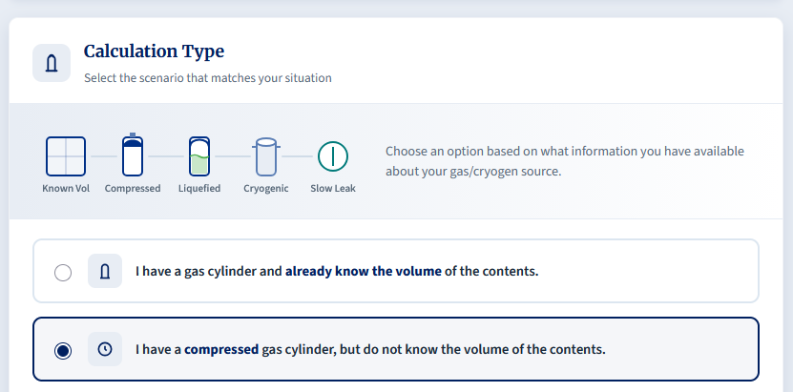
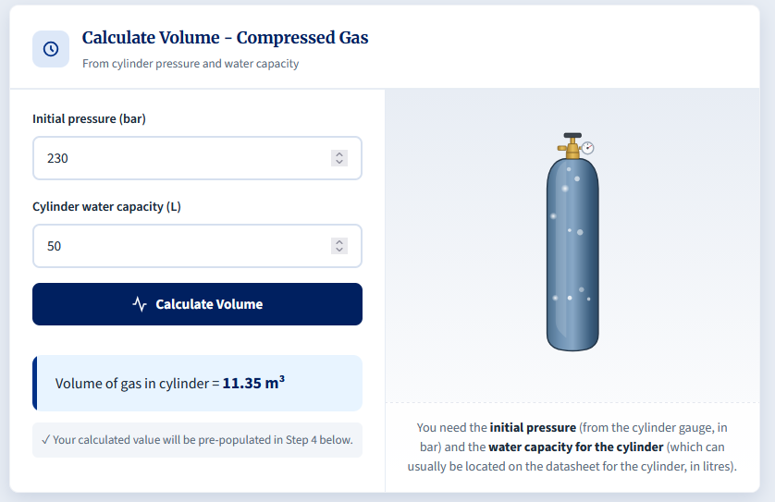
After clicking Calculate Volume, we obtain a value of 11.35m³, and this corresponds to the volume of gas within the cylinder.
After this, we continue through the calculator and are prompted to enter the room's free air volume. The gas volume calculated in the previous step is automatically populated in the relevant field, so no manual entry is required.
We input the free air volume and selected “Asphyxiant” as the gas hazard type.
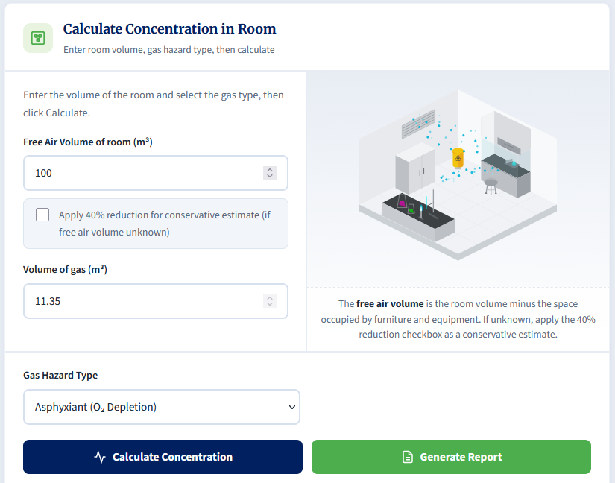
After this, the concentration of O₂ in the room is displayed in the event of a catastrophic release.
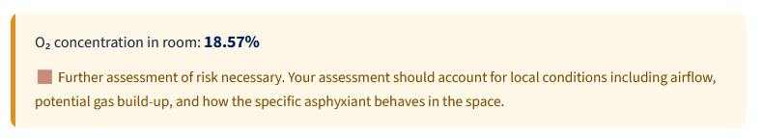
Similarly, a personal bubble calculation is automatically calculated as part of the process. This simulates the O₂ concentration in a 2x2x3 bubble immediately around the cylinder.
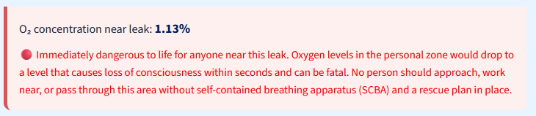

Scenario 2: Liquefied Gas (Toxic)
Answers:
- Gas Volume: 14m³.
- Room Concentration: 466,666.67ppm.
  - Methodology: The 40% reduction drops the 50m³ room to an effective free air volume of 30m³.
Explanation:
This scenario is asking us to determine the volume of Ammonia gas that can be contained within a cylinder of liquefied contents. The phase of the medium is different compared to a compressed gas cylinder, but we can still calculate the volume of gaseous contents that the cylinder contains.
This time, we select: “I have a liquefied gas cylinder, but do not know the volume of the contents.”
This scenario provides the mass of the gas contents only. Care should be taken, as some suppliers quote the combined weight of the cylinder and its contents; for this calculation, only the mass of the gas is required. The specific volume of gas is also provided. This value is gas-specific and can usually be found from reliable online sources. Engineering Toolbox is a useful reference, although not all gases are listed there.
We simply enter both the weight of contents and specific volume and click “Calculate Volume”.
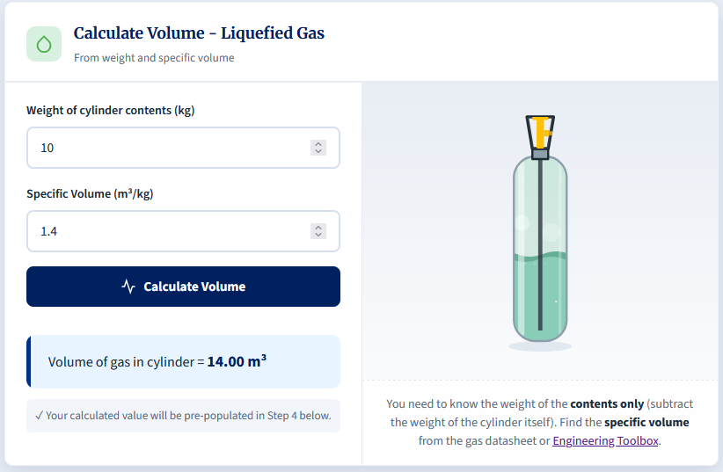
This calculation gives a volume of 14m³.
As before, we move further down the calculator to determine the final room gas concentration following a catastrophic release.
The room volume is 50m³, but as the amount of furniture and equipment is unknown, a 40% reduction is applied to estimate the free air volume. This is a conservative approach; where rooms are known to be heavily cluttered, a more accurate free air volume can be obtained by subtracting the volume of equipment from the total room volume.
For this scenario, "Toxic" is selected as the gas hazard type before running the calculation.
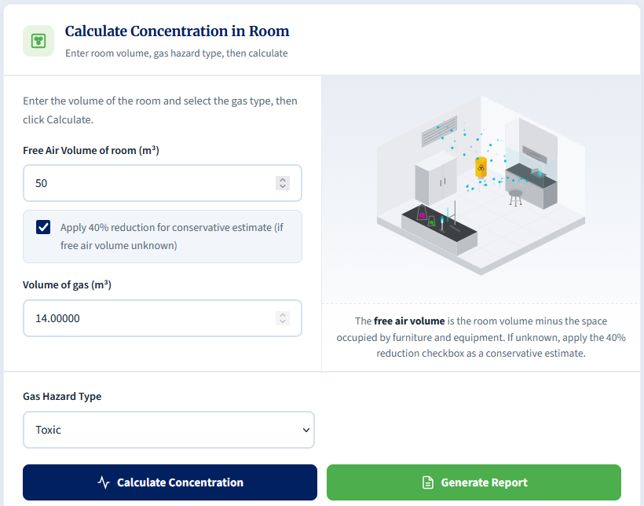
For toxic gases, the calculated concentration on its own is not enough to make a recommendation, as exposure limits vary between chemicals. The result must be compared with the appropriate workplace exposure limit (WEL).
In this example, the calculated room concentration of 466,667 ppm would far exceed typical WELs, meaning additional controls would likely be needed for most toxic gases to protect users.
For completion, the WEL for ammonia is 25ppm, so a catastrophic loss would greatly exceed the exposure limit, and controls would be a necessity.
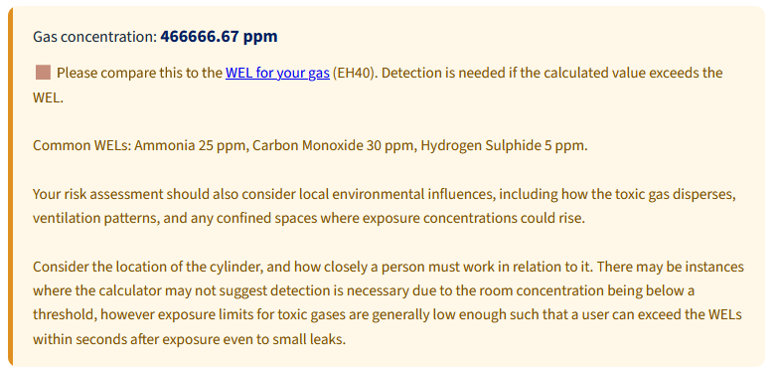

Scenario 3: Cryogenic Vessel (Asphyxiant)
Answers:
- Gas Volume Generated: 17.35m³.
  - Methodology: Liquid Nitrogen (LN₂) expands dramatically, multiplying by an expansion ratio of approximately 694.
- Room O₂ Concentration & Recommendation: 18.53%.
  - Recommendation: The calculator categorises levels between 18% and 19.5% as requiring further risk assessment, noting to account for local conditions, airflow, and gas build-up.
Explanation:
When cryogenic liquids boil, they rapidly expand creating hundreds of times the volumes of the initial liquid. This can very quickly create an asphyxiation risk.
We begin by calculating the volume of the gas after expansion by selecting the option: “I have a Cryogenic vessel (Dewar / Tank).”
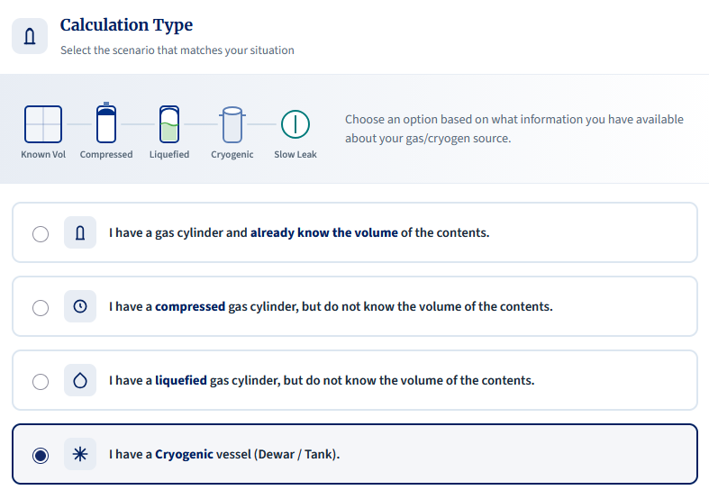
Next, select the cryogen being used and enter the known contents of the vessel. If the contents are uncertain, use the maximum supported capacity (the largest volume the vessel is designed to safely contain).
In this instance, we know it holds 25L of liquid nitrogen (LN₂), so we enter that into the calculator and click “Calculate Volume”.
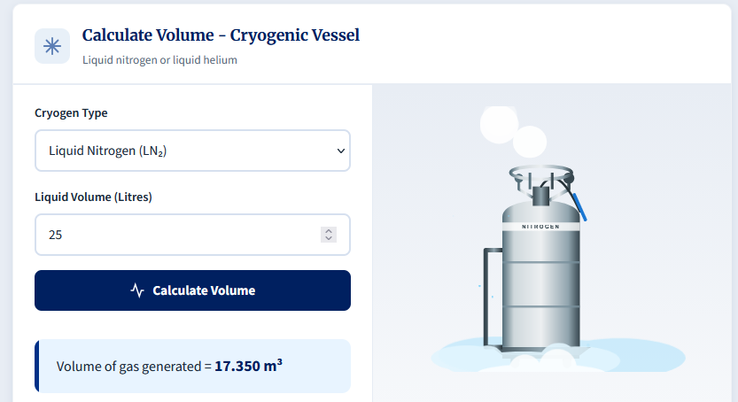
This shows us that this dewar could release up to 17.35 m³ of nitrogen gas.
Scrolling down, we can then calculate the room concentration. The free air volume is already known and is automatically populated in the calculator, so no manual entry is required. We then click "Calculate Concentration".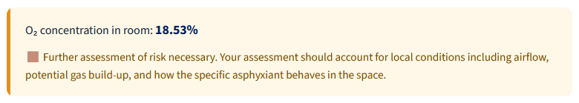
The calculator indicates that further risk assessment is required.
Although room ventilation is likely to prevent oxygen levels from dropping to hazardous levels, there may still be a local asphyxiation risk if a user works close to the source of the leak. When liquid nitrogen is released, the cold nitrogen gas produced may initially collect at low level before warming and mixing, increasing the risk of localised oxygen depletion near the floor.
In situations like this, the hierarchy of control should be applied. Where possible, risks should be reduced by measures such as using smaller dewars (where liquid nitrogen is essential) and ensuring that ventilation is sufficient to control residual risk. Gas detection can also be considered to alert users to leaks, but whether this is required should be determined through risk assessment, considering working practices, occupancy and existing controls.
In addition to the gas risk, the assessment must also consider the hazards associated with direct exposure to cryogenic liquids.

Scenario 4: Known Volume (CO₂ Enrichment)
Answers:
- Room Concentration: 3.75%.
- Detection Required?: Yes.
  - Methodology: The calculator states that CO₂ detection is required if the concentration is above 0.5% (or 5000ppm) (these values are the WELs for CO₂ as found in EH40)
Explanation:
In this example, we are provided with the volume of gas in the cylinder already (1.5m³). Some suppliers will provide this information up front on their website or guidance sheet. Knowing this makes the calculation much easier to complete, and if they have measured the gaseous contents, this is usually more accurate as it considers the “non-ideal” nature of gases.
Knowing the volume of CO₂ in the cylinder already, we can select the option: “I have a gas cylinder and already know the volume of the contents.”
From there, we simply enter the values from the scenario, select Carbon Dioxide from the Gas Hazard Type dropdown, and click “Calculate Concentration”.
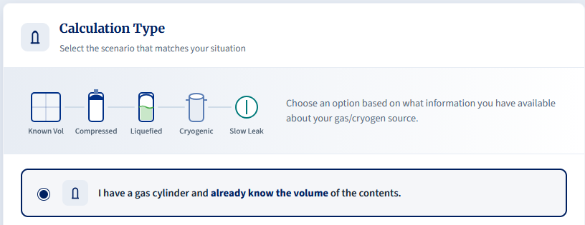
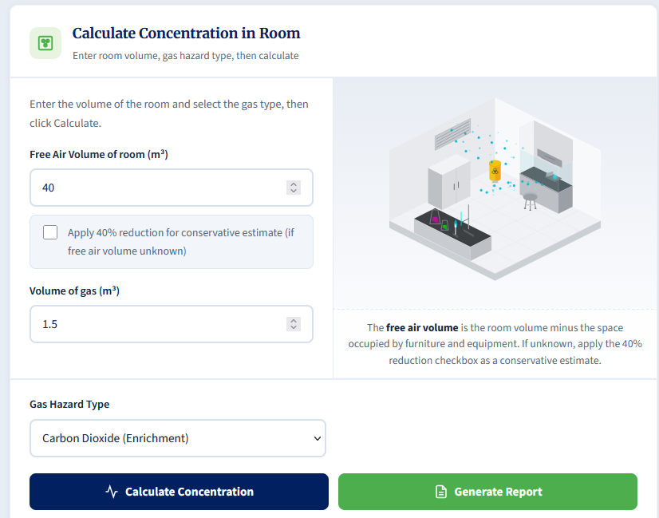
This displays a room concentration of 3.75% CO₂. As indicated below, the recommendation is such that detection must be considered as this level of gas release is well above the 0.5% limit.
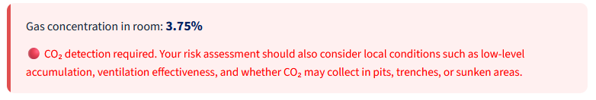

Scenario 5: Slow Leak (Flammable)
Answer:
- Steady-State Concentration: 0.21%.
Explanation:
Calculating the volume of a slow leak is not an exact science, and this calculator should be used with caution. If values are not known or measurable, then coming to an accurate conclusion on the risk to a person is difficult. Where possible, avoid estimating leak rates and air-change rates; these should be measured rather than estimated.
In this scenario, the leak rate is measured as 1 m³/hr. We begin by selecting the slow leak calculator:
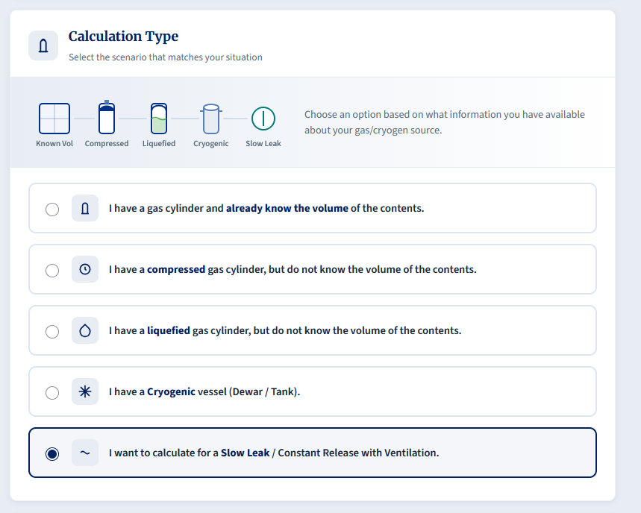
After this, we can enter all the details from the scenario into the calculator. We enter the measured leak rate of 1 m³/hr, then the air changes per hour (6 ACH) and the free air volume (80 m³). We then select Flammable as the Gas Hazard Type and click Calculate.
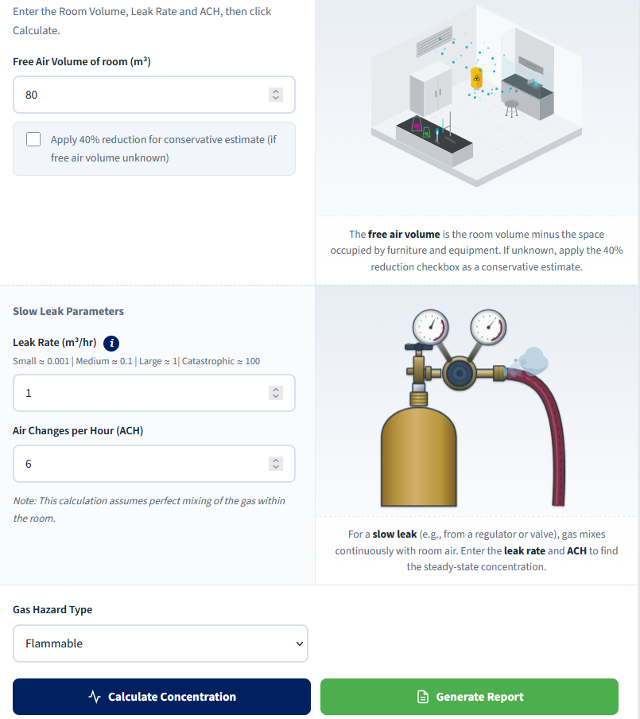
We end with a steady-state concentration of 0.21%. This is below 25% of the value of LELs for common flammable gases such as hydrogen and methane. The need for detection remains dependent on the specific gas, its LEL, local accumulation, ignition sources, and the proximity of work.
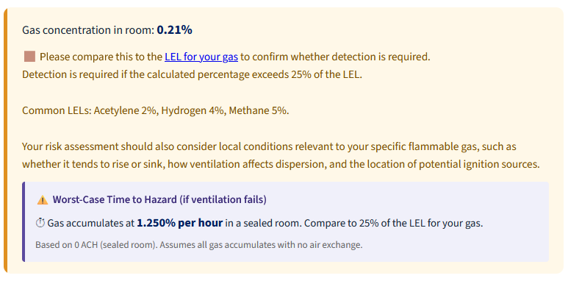

Scenario 6: Toxic Gas, External Lookups & Detection Placement
Answer:
- Gas Volume: 0.5m³.
  - Methodology: A standard BOC size 'AV' cylinder has a cylinder capacity of 500 Litres. To convert from L to m³, we divide by 1000, which equals 0.5m³ of CO.
- Room Concentration: 6250 ppm.
- WEL & Detection Requirement: Yes, detection is required. The internal guidance notes a common WEL for CO is 20 ppm.
- Detector Type & Placement: Electrochemical sensor, mounted at breathing zone height (approx. 1.5m - 1.8m).
  - Methodology: Toxic gases require electrochemical sensors. CO has a density similar to air, so it is mounted at typical breathing height.
Explanation:
When calculating risks from compressed gas or cryogen hazards, we will likely need to search for the relevant data in order to carry out calculations. Different providers will provide different information which can make the process harder.
In this instance, we know the gas is Carbon Monoxide and the cylinder is an AV cylinder from BOC. We will need to visit their website to locate the details for the cylinder.
In this instance, the site lists 500L as the capacity for an AV cylinder, which corresponds to 0.5m³ of gas.
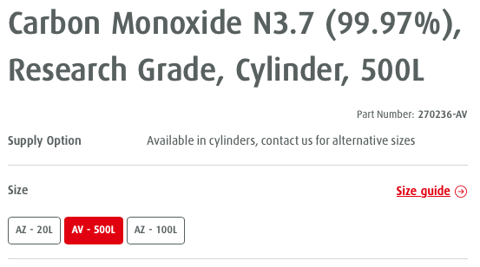
As we already know the gas volume (500L = 0.5m³), we can skip that calculation and go straight to “I have a gas cylinder and already know the volume of the contents.”
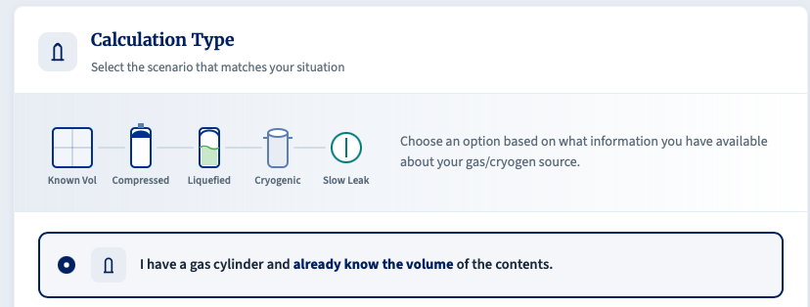
After selecting that, we enter the gas volume and free air space, as normal. We then select Toxic under the Gas Hazard Type and then Calculate Concentration.
By clicking calculate, we see that the room concentration will reach 6250 ppm if there is a catastrophic release.

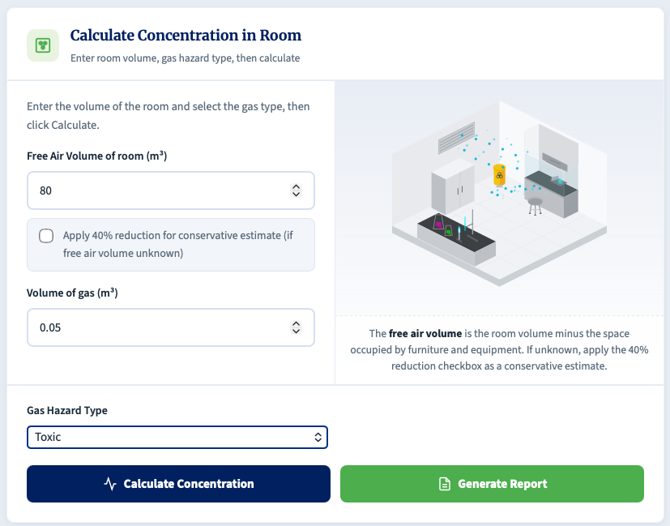
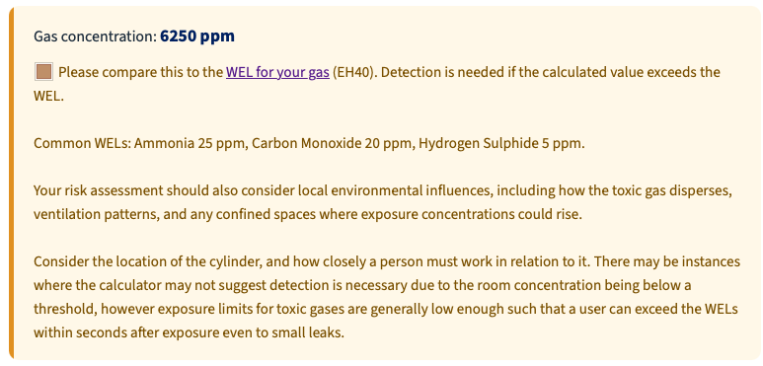
If we go to EH40 (linked in the calculation box within the calculator), we should check the applicable Carbon Monoxide exposure limits listed there. In practice, both the long-term and short-term exposure limits should be considered when interpreting the calculator output.
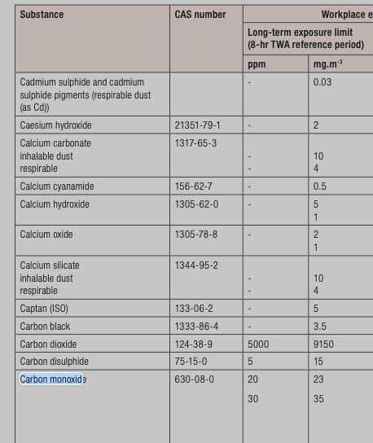
As a catastrophic release would be far above the relevant exposure limits, and because local concentrations near the source would also exceed the room average, detection and additional controls would be expected.
If we then click the “Generate Report” button in the calculator and scroll down, it can also provide recommendations for different types of detection as well as heights.
In this instance, the detector to be used would be an electrochemical sensor that would detect CO, and it would ideally be mounted in the breathing zone (between 1.5m – 1.8m) as the molecular weight of the gas is similar to that of air.
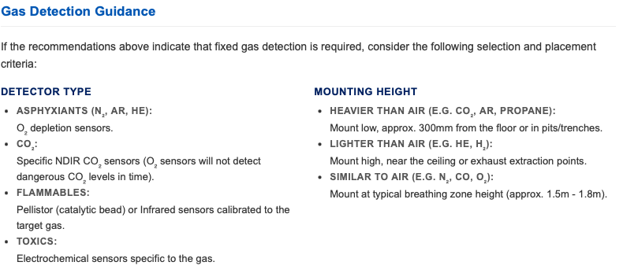

Scenario 7: Slow Leak, Time to Hazard & Heavy Gas Detection
Answer:
- Steady-State Concentration: 0.11%.
- Time to Hazard (to 0.5%): Approximately 2hrs 18 mins.
- Detector Type & Placement: If detection were required, the calculator guidance indicates that a specific NDIR CO₂ sensor mounted low (approx. 300 mm from the floor) would be appropriate.
  - Methodology: Standard oxygen-depletion sensors do not replace dedicated CO₂ sensors. Although CO₂ will eventually mix with room air, it can accumulate at low level when released, particularly when cold, so CO2-specific detection is required. The onset of the risk to health from CO₂ gas is also much faster than the asphyxiation risk, and therefore it is important that CO₂ leaks are detected as fast as possible.
Explanation:
As previously mentioned, calculating the volume of a slow gas leak is not an exact science, and the calculator should therefore be used with caution. If key values are not known or cannot be measured, it becomes difficult to draw accurate conclusions about the risk to individuals.
Where possible, leak rates and air-change rates should be measured rather than estimated. If this is not reasonably practicable, a conservative worst-case approach should be applied. In this scenario, we know the gas, the size of the leak and the air changes we have (assuming all have been measured/confirmed).
Once again, we use the option for “I want to calculate for a Slow Leak / Constant Release with Ventilation.”
We can enter the free air volume but will need to calculate the leak rate. We can do this by selecting 'Estimate Leak Rate' and entering the regulator gauge pressure and equivalent hole diameter from the scenario.
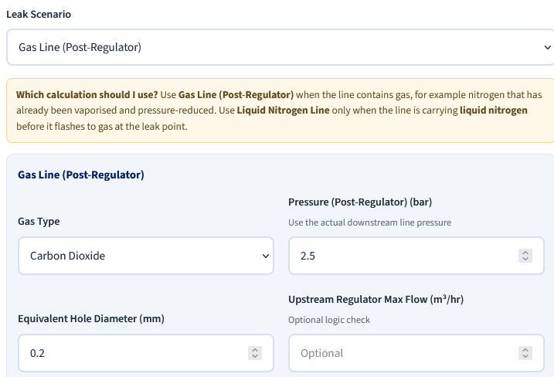
Note: We enter the regulator gauge pressure reading in bar(g), exactly as shown on the regulator, not a separately adjusted line pressure.
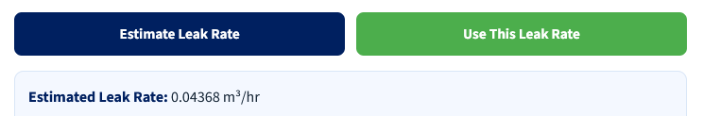
We then click Estimate Leak rate, which will be shown underneath the button. You can then click “Use this Leak Rate” to feed the value into the calculator.
We can then enter the Air Changes per Hour, selected Carbon Dioxide (Enrichment), and click Calculate Concentration.
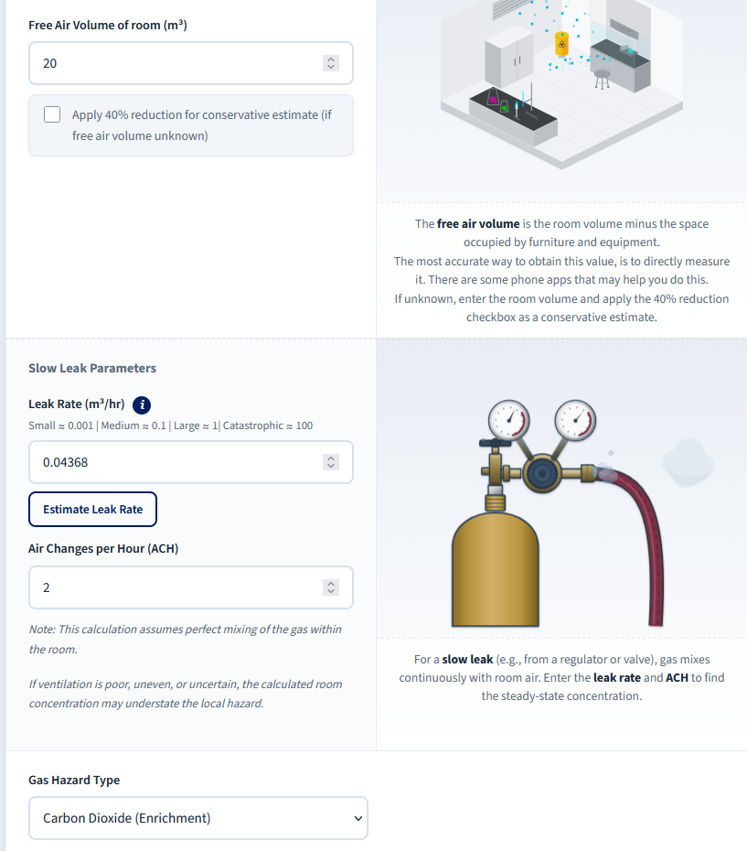
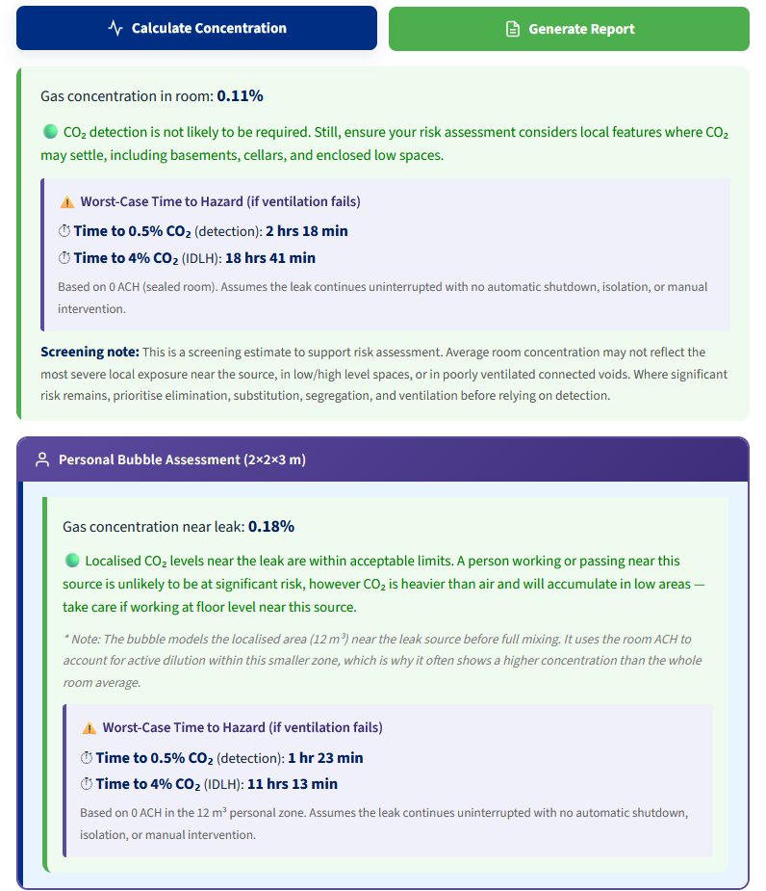
The steady-state room concentration is calculated as 0.11%, indicating that the room-average risk after full mixing is relatively low on a screening basis.
In the event of a complete ventilation failure, gas would begin to accumulate in the room, as the ability for contaminated air to be removed is lost. In this scenario, the calculator provides a "Time to Hazard" estimate, indicating that the room would reach the 0.5% CO₂ threshold after approximately 2 hours and 18 minutes. This value represents a warning threshold for further action, not an indication that conditions remain acceptable up to that point.
Review of the generated report also provides guidance on the appropriate type of gas detection, although this scenario does not result in a blanket recommendation for detection. Where detection is required, the guidance indicates that an NDIR CO₂ sensor should be used and mounted at low level, typically around 300 mm above floor height.
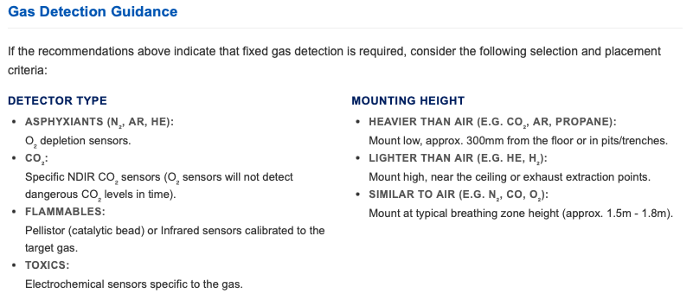

Scenario 8: Calculation Risk of Exposure when handling Dry Ice
Answer:
Maximum volume of CO₂ gas generated: 0.108m³
Local Risk Present? The personal bubble assessment indicates a local concentration of 0.9%, so the calculator supports further assessment rather than a blanket conclusion that the task is low risk. The real significance depends on sublimation rate, duration, local airflow, and the worker's breathing-zone position relative to the dry ice.
Explanation:
For this calculation, we will look to use the Dry ice calculator, which can be accessed by clicking the “I have dry ice (solid CO₂) and want gas volume from a known mass.” button.
We know that we have 200g of Dry ice, which is 0.2kg – we enter that into the field and click Calculate Volume. The calculator returns a gas volume of 0.108m³.
We can then continue down the calculator to determine the room concentration following equilibration, as well as the personal bubble assessment.
As the free air volume is already known, it is entered into the relevant field. The calculated gas volume is automatically populated, and the Gas Hazard Type is pre-selected.
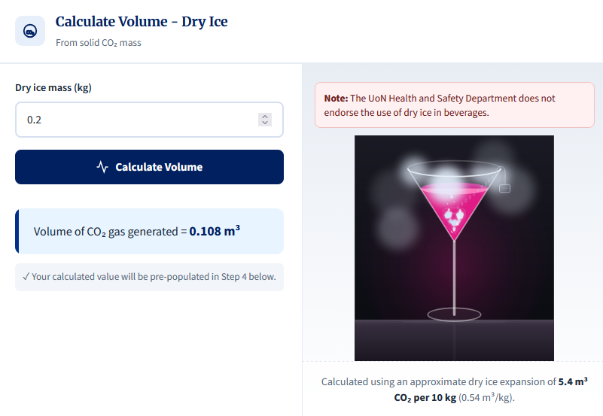
Click "Calculate Concentration" to obtain both the room-average and personal bubble concentrations. In this scenario, we are primarily interested in the personal bubble result, which is calculated as 0.9%.
Note: The calculator provides a generalised indication of potential risk, and the specific activity being undertaken must always be considered carefully. The personal bubble assumes a 2m x 2m x 3m zone around the source of release; however, if a user is handling dry ice close to their breathing zone (for example, within 50cm), the actual local risk may be higher than this simplified assumption suggests. In addition, carbon dioxide gas generated from sublimation may initially accumulate at low level rather than rising and dispersing immediately.
This calculation assumes an instantaneous release and therefore represents a worst-case scenario. As the calculated concentration exceeds the 0.5% threshold, the output indicates that further risk assessment is required, taking into account the factors described above.
This calculation is for instantaneous release and calculates a worst-case scenario. Given the limit of 0.5%, we would appear to be above this so this calculation would determine that a further assessment of risk is necessary. For this, we need to expand our analysis to include the factors mentioned above.
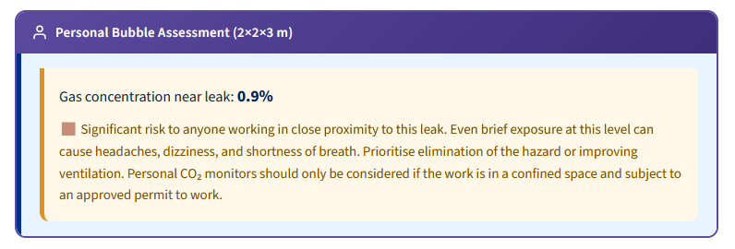
For larger quantities of dry ice, a more detailed assessment may be required. In such cases, it may be appropriate to consider the sublimation rate to better understand potential exposure, recognising that this introduces additional complexity beyond this screening approach.

Scenario 9: Mixed Gas Cylinders & Multiple Independent Risks
Answer:
Gas Volume: 9.67m³. (Using the supplier volume for the cylinder contents.)
CO₂ Hazard: The CO₂ gas volume is 0.967m³ (10% of total). This results in a room CO₂ concentration of 3.22%, which is well above the calculator's 0.5% CO₂ threshold.
Hydrogen Hazard: The H₂ gas volume is 0.967m³ (10% of total). This results in a room H₂ concentration of 3.22%, which is above 25% of the LEL for hydrogen (1%).
Oxygen Depletion: The total gas release (9.67m³) displaces air, resulting in a room O₂ concentration of approximately 14.20%.
Detector Strategy: All three hazards are significant, but they do not reach their respective thresholds at the same point. On a room-average basis, the CO₂ threshold is reached first, followed by oxygen depletion, and then the hydrogen 25% LEL threshold.
Recommendation: On a room-average screening basis, a CO₂ detector is likely to provide the earliest alarm. That does not make oxygen depletion or hydrogen-related controls automatically redundant; the final detector strategy should be confirmed from the actual release scenario, room layout, ventilation pattern, and work location.
Explanation:
When assessing mixed-gas cylinders, it is important to understand both the physical properties of the cylinder and the hazards presented by each gas component.
In this scenario, the cylinder is a standard BOC size 'L' cylinder. BOC provides this value directly for this gas mixture, stating that the cylinder contains approximately 9.67m³ of gas in atmospheric conditions.
Although a slightly different value (e.g. 9.87m³) could be calculated using the pressure of the cylinder and the water capacity, the supplier-stated free air volume is preferred, as it accounts for real-gas behaviour and filling practice. For this reason, 9.67m³ is used in the calculation.
The gas mixture comprises 10% CO₂, 10% H₂ and 80% N₂ so the individual component volumes are:
- CO₂ - 0.967m³
- H₂ - 0.967m³
- N₂ - 7.74m³
As all components act as asphyxiants, the oxygen depletion risk is assessed using the total released volume (9.67m3).
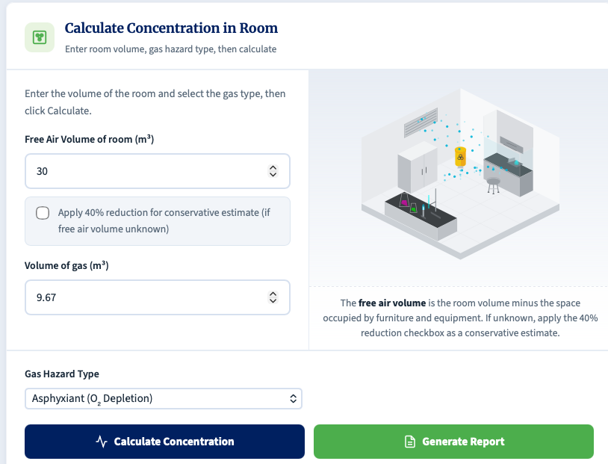
This results in a calculated room oxygen concentration of approximately 14.2%, indicating a risk of asphyxiation.
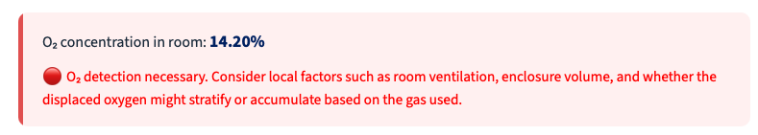
The CO₂ enrichment risk is then assessed separately using the CO₂ component volume (0.967m³), resulting in a room concentration of 3.22%, which exceeds the calculator's 0.5% CO₂ threshold.
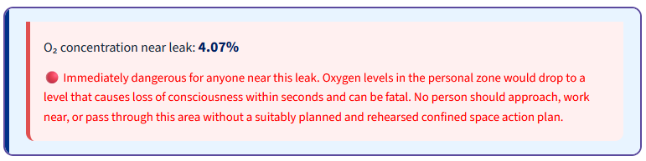
Similarly, this indicates we have the potential to create a hazardous environment in the event of a catastrophic release.
Finally, the hydrogen flammability risk is assessed using the hydrogen component volume (0.967m³). This produces a room concentration of 3.22%, exceeding 25% of the Lower Explosive Limit (1%).
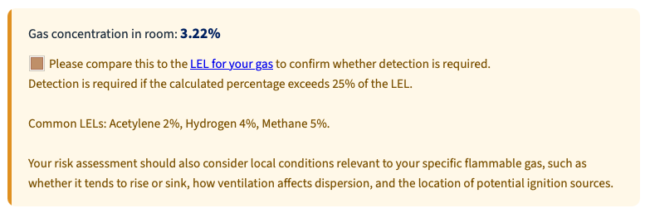
In this instance, we are at 3.22%, which exceeds 25% of the LEL for H₂ (1%).
As we can see, all three identified hazards have the potential to create a safety risk, but for different reasons.
In practice, a mixed-gas release should not be thought of as each component immediately behaving in isolation. The escaped gas will initially behave as a plume, and its movement will depend mainly on the overall properties of the released mixture, the release momentum, ventilation, and the room layout.
The calculator is therefore most useful for identifying which hazard threshold is reached first on a screening basis. That helps indicate which detector may provide the earliest warning, but it does not by itself prove that one detector is always sufficient or that other hazards can be ignored.
On a room-average screening basis, the CO₂ threshold is reached first, indicating that a CO₂ detector is likely to provide the earliest general warning. However, this does not mean that oxygen-depletion or hydrogen-related controls are redundant. The final detector strategy should be determined by the specific release scenario, room layout, ventilation pattern, and work location and should be confirmed by a competent gas detection specialist.

Part 3: Gas/Cryogen Safety Calculator: Methodology, Equations and Assumptions
This document outlines the theoretical models and formulas utilised by the Gas/Cryogen Safety Calculator, based on the methodology detailed in example questions.

1. Volume Calculations
Before any concentration can be determined, the total volume of gas (measured at standard atmospheric pressure and temperature) must be calculated from the initial source parameters.
1.1 Compressed Gas Volume
This calculation is approximated using Boyle's Law (P₁V₁ = P₂V₂), assuming constant temperature, expanding the cylinder's internal capacity to standard atmospheric pressure.
$$V_{gas}=\frac{P_{cyl}×\left(\frac{V_{water}}{1000}\right)}{1.013}$$
Where:
V_{gas} = Total expanded volume of the gas (m³)
P_{cyl} = Initial pressure of the cylinder (bar)
V_{water} = Water capacity of the cylinder (Litres)
1000 = Conversion factor (Litres to m³)
1.013 = Standard atmospheric pressure (bar)
1.2 Liquefied Gas Volume
A direct mass-to-volume conversion using the specific volume of the gas at standard conditions.
$$V_{gas}=W×SV$$
Where:
V_{gas} = Total expanded volume of the gas (m³)
W = Weight of the liquefied contents (kg)
SV = Specific Volume of the specific gas (m³/kg)
1.3 Cryogenic Gas Volume
Utilises standard liquid-to-gas expansion ratios.
$$V_{gas}=\frac{V_{liquid}×E_{R}}{1000}$$
Where:
V_{gas} = Total expanded volume of the gas (m³)
V_{liquid} = Volume of the cryogenic liquid (Litres)
E_{R} = Expansion Ratio (e.g., 694 for Liquid Nitrogen, 757 for Liquid Helium)
1000 = Conversion factor (Litres to m³)

2. Room Concentration (Instantaneous Release)
This model assumes a catastrophic failure where the entire container contents are released immediately and mix perfectly into the room.
2.1 General / Flammable / CO₂ Concentration (%)
$$C_{\%}=\left(\frac{V_{gas}}{V_{room}}\right)×100$$
Where:
C% = Resulting concentration of the gas in the room (%)
V_{gas} = Total expanded volume of the gas (m³)
V_{room} = Free air volume of the room (m³)
2.2 Toxic Gas Concentration (ppm)
$$C_{ppm}=\left(\frac{V_{gas}}{V_{room}}\right)×1,000,000$$
Where:
C_{ppm} = Resulting concentration of the gas in the room (parts per million)
2.3 Oxygen Deficiency (Asphyxiant Concentration)
This calculation assumes that the gas released from the cylinder forces an equivalent volume of perfectly mixed 'normal air' out of the room. It assumes normal clean air contains exactly 20.95% oxygen by volume in an instantaneous release.
$$O_{2(\%)}=\left(\frac{\left(V_{room}-V_{gas}\right)×0.2095}{V_{room}}\right)×100$$
Where:
O_{2(%)} = Resulting oxygen concentration in the room (%)
0.2095 = Standard volume fraction of oxygen in normal air (20.95%)
2.4 Oxygen Enrichment
This calculates the concentration when pure oxygen is released into a room, accounting for the displacement of standard room air (assumed 21% baseline for this specific calculation).
$$O_{2\backslash \%}=\left(\frac{\left(V_{room}×0.21\right)+V_{gas}-\left(0.21×V_{gas}\right)}{V_{room}}\right)×100$$

3. Continuous Slow Leak (Steady-State)
This models a steady leak into a room with active ventilation. Based on a simplified steady-state mass balance equation, the room reaches 'steady state' when the rate of the hazardous gas entering exactly equals the rate of mixed air extracted.
3.1 Ventilation Rate (Q)
$$Q=V_{room}×ACH$$
Where:
Q = Volumetric flow rate of ventilation (m³/hr)
ACH = Air Changes Per Hour (hr⁻¹)
3.2 General / Flammable / CO₂ Concentration (%)
$$C_{/\%}=\left(\frac{L}{Q}\right)×100$$
Where:
L = Leak Rate of the gas into the room (m³/hr)
3.3 Toxic Gas Concentration (ppm)
$$C_{ppm}=\left(\frac{L}{Q}\right)×1,000,000$$
3.4 Oxygen Deficiency (Asphyxiants)
Calculates the depressed equilibrium of oxygen levels (using a 20.9% baseline).
$$O_{2\%}=20.9×\left(1-\frac{L}{Q}\right)$$
3.5 Oxygen Enrichment
Calculates the increased equilibrium oxygen concentration using a 20.9% ambient air baseline and a steady-state mass-balance approach. In the current calculator, oxygen enrichment is treated as an addition above normal air, rather than assuming the incoming oxygen replaces air with 100% oxygen.
$$O_{2\%}=20.9+\left(\frac{L}{Q}×100\right)$$

4. Worst-Case Time to Hazard (0 ACH)
This calculates the time required to reach a dangerous threshold if all building ventilation completely fails (0 ACH worst-case). It should be treated as a screening model with no ventilation removal, not as a literal sealed or pressurised box.

4.1 Oxygen Deficiency (Time to 19.5% and 18%)
Utilises a logarithmic decay function to find when the oxygen level drops to specific warning and danger thresholds.
Time to 19.5% (Warning Level):
$$t_{19.5}=\left(\frac{V_{room}}{L}\right)×\ln\left(\frac{20.9}{19.5}\right)$$
Time to 18.0% (Danger Level):
$$t_{18.0}=\left(\frac{V_{room}}{L}\right)×\ln\left(\frac{20.9}{18.0}\right)$$
Where:
t = Time required to reach the target concentration (hours)
ln = Natural logarithm
4.2 Gas Concentration (Time to 0.5% and 4% CO₂)
Utilises a logarithmic accumulation function for gases displacing room air.
Time to 0.5% (Detection/Warning):
$$t_{0.5}=-\left(\frac{V_{room}}{L}\right)×\ln\left(1-0.005\right)$$
Time to 4.0% (Immediately Dangerous to Life or Health (IDLH) limit):
$$t_{4.0}=-\left(\frac{V_{room}}{L}\right)×\ln\left(1-0.04\right)$$
4.3 Oxygen Enrichment (Time to 23.5%)
Calculates the time until standard air is enriched to the critical 23.5% threshold.
$$t_{23.5}=-\left(\frac{V_{room}}{L}\right)×\ln\left(\frac{100-23.5}{100-20.9}\right)$$
4.4 Flammable / Toxic Linear Accumulation
Because standard exposure limits (LEL and WEL) vary drastically by specific gas, the calculator outputs a linear accumulation rate per hour for the user to compare against their specific gas limits.
Flammable Rate (% per hour):
$$Rate_{\%}=\left(\frac{L}{V_{room}}\right)×100$$
Toxic Rate (ppm per hour):
$$Rate_{ppm}=\left(\frac{L}{V_{room}}\right)×1,000,000$$

5. Dry Ice Conversion
The dry ice calculator converts solid CO₂ mass to equivalent gas volume using a fixed expansion factor of 0.54 m³/kg. This is intended as a practical approximation for the maximum gas volume generated by sublimation.
Where:
$$V_{gas}= m_{dry} × 0.54$$
m_{dry} ice = mass of dry ice (kg)

6. Advanced Leak-Rate Estimator
The advanced leak-rate estimator provides a rough leak-rate input for the Slow Leak calculation when a measured leak rate is not available. It is a screening method only and should not be treated as a detailed flow-calculation tool.
6.1 Gas Line (Post-Regulator)
For choked flow (gas escaping through small hole & reaches the speed of sound) post-regulator gas leaks, the calculator estimates leak rate from regulator gauge pressure, equivalent hole diameter, and a gas factor. The gauge pressure is first converted internally to absolute pressure.
$$Q=0.4 × D^{2} × {(P}_{gauge}+1) × F_{g}$$
Where:
P_{gauge} = Regulator gauge pressure in bar(g)
D = Equivalent hole diameter (mm)
F_{g} = Gas-specific factor
This calculator uses an approximation formula for quick estimates. It assumes choked flow through a standard sharp-edged orifice at room temperature (~20°C). The baseline calculation is optimised for the thermodynamic properties of Air, but when selecting other gases, the factor adjusts for molecular weight.
Because of the approximations used, there may be an error margin of up to, approximately, 6% depending on the gas.
6.2 Liquid Nitrogen Line
For LN₂ line leaks, the calculator estimates the equivalent gaseous nitrogen hazard rate for oxygen-deficiency screening rather than the liquid flow rate itself.
Where:
$$Q_{{LN}_{2}, gas}=19.3×D^{2}× \sqrt{P_{gauge}}$$
P_{gauge} = Gauge pressure in bar
D = Equivalent hole diameter (mm)

6.3 Regulator Maximum Flow Cap
If an upstream regulator maximum flow is entered, the calculator applies a logic cap so that the leak rate used in the Slow Leak model cannot exceed the maximum flow the regulator can physically supply.

7. Recommendation and Threshold Logic
The calculator does not use a single generic risk rule for every gas. It applies different screening thresholds depending on the selected hazard type.
Asphyxiants: room oxygen below 19.5% prompts further assessment, and below 18% indicates a severe oxygen-deficiency risk.
Oxygen enrichment: oxygen above 23.5% indicates an enrichment risk requiring control.
CO₂: room concentration above 0.5% triggers the calculator CO₂ warning threshold, with higher local concentrations indicating more serious proximity risk.
Flammables: the calculator reports concentration and asks the user to compare it with the gas-specific LEL, including 25% of the LEL as the key screening threshold used in the current interface.
Toxics: the calculator reports ppm and requires comparison against the applicable occupational exposure limits for the specific gas.

8. Personal Bubble Assessment
A secondary calculation applied simultaneously to all scenarios to estimate the localised concentration immediately surrounding the leak.
It uses the exact same equations outlined in Sections 2, 3 and 4, but applies them to a smaller fixed zone.
The room volume (Vr_{oom}) is strictly replaced with 12m³ (representing an arbitrary 12 m³ workspace / 2 x 2 x 3 m zone).

